Week 2 Time Management Assignment
An assignment you will submit to the Dropbox this week is the Time Management Assignment. This week is the right place and time to talk about time management. It is still early enough in the session to resolve any issues that may affect your success, namely any issues you have with managing your time.
This assignment involves accessing a resource titled SuccessU.
Within SuccessU, there are several modules. You will watch the Time Management module this week to complete this assignment.
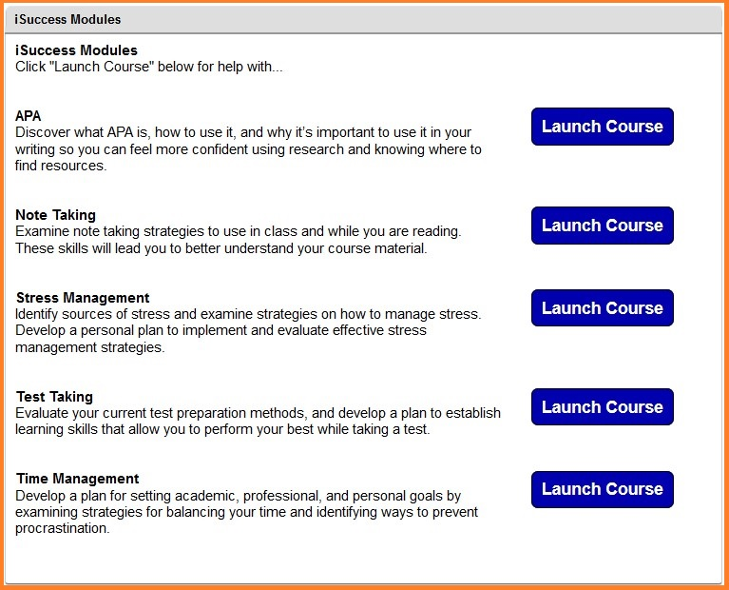
Next, write a reflection paper on your own time management approach. Write your reflection in a Microsoft Word document. Then, submit it to the Dropbox.
In your completed assignment, describe your approach to managing your time. Then, discuss the issues that impact your time management most. Finally, describe two strategies that you can implement to more effectively manage your time.
Refer to the grading rubric below to understand how this assignment will be graded.

Grading Rubric
Graded Item | Description | Good/Fair/Poor/Incomplete
Reflecting on Time Management Behaviors | Completed assignment is a well-developed self-reflection. It is a thorough analysis of current time management approach. It includes a brief discussion of the issues impacting the management of time. Two strategies are discussed that are clear and specific in how the strategies can be implemented. It is insightful and demonstrates critical thinking. It is approximately two to three paragraphs. | 40/30/10/0
Writing, Mechanics, and Grammar | Paragraphs are focused and flow from idea to idea. The completed assignment is not a collection of random thoughts.  Writing is clear. Student has elaborated on the insights gained and used examples to provide further clarity.  Writing is correct. Any errors in spelling, punctuation, and grammar do not interfere with meaning. | 10/5/2/0
Total Points Earned
Total Points Possible |  | 50

